Key metabolites in tissue extracts of Elliptio complanata identified using ¹H Nuclear Magnetic Resonance (NMR) spectroscopy
Jennifer L. Hurley-Sanders^{1,2,5}, Jay F. Levine^{1,5,*}, Stacy A. C. Nelson², J. M. Law^{1,5}, William Showers³, Michael K. Stoskopf^{4,5}

Corresponding author:
Jay Levine
Department of Population Health and Pathobiology, College of Veterinary Medicine, Box 8401, North Carolina State University, Raleigh, NC, USA 27607; jay_levine@ncsu.edu

- Department of Population Health and Pathobiology, College of Veterinary Medicine, Box 8401, North Carolina State University, Raleigh, NC, USA 27607; E-Mail: jlhurley@ncsu.edu (J.L.H.S.), jay_levine@ncsu.edu (J.F.L.), mac_law@ncsu.edu (J.M.L)
- Department of Forestry and Environmental Resources, College of Natural Resources, Box 7106, North Carolina State University, Raleigh, NC, USA, 27695; E-Mail: stacy_nelson@ncsu.edu
- Department of Marine, Earth, and Atmospheric Sciences, College of Sciences, Box 8208, North Carolina State University, Raleigh, NC, USA, 27695; E-Mail: w_showers@ncsu.edu
- Department of Clinical Sciences, College of Veterinary Medicine, Box 8401, North Carolina State University, Raleigh, NC, USA 27607; E-Mail: michael_stoskopf@ncsu.edu
- Environmental Medicine Consortium, North Carolina State University, Raleigh, NC, USA 27607

Lay Summary:
We used ¹H-NMR to describe the key components of the metabolome of the freshwater mussel, Elliptio complanata. Variability across tissue types was evaluated using principal components analysis. Muscle, digestive gland, mantle and gill tissues yielded metabolic profiles with potentially valuable biomarkers of mussel physiologic function. These preliminary studies provide evidence that metabolomic assessment of digestive gland may be useful in studies of the impacts of location on E. complanata and metabolomic assessment of and mantle tissue most useful for studies of the impacts of sex and reproductive condition on mussel physiology..

Total word count: 3477 - not including tables or references

Abstract
We used ¹H-nuclear magnetic resonance (NMR) spectroscopy to describe key meabolites of the polar metabolome of the freshwater mussel, Elliptio complanata. Variability across tissue types was evaluated in mussels collected from the Eno River, Hillsborough, NC, and New Hope Creek, Durham, North Carolina, USA using principal components analysis. Muscle, digestive gland, mantle and gill tissues yielded identifiable but overlapping metabolic profiles. Digestive gland metabolic profiles varied between the two rivers characterized by differences in mono- and disaccharides. Mantle tissue metabolomes varied by gender. Nuclear magnetic resonance spectroscopy is a sensitive means to detect metabolites in the tissues of Elliptio complanata and holds promise as a tool for the investigation of freshwater mussel health and physiology.
Introduction
The ecological niche filled by suspension feeding bivalve mollusks makes them well suited to serve as biologic monitors of aquatic ecosystems. As filter feeders, they are exposed to suspended solids and dissolved chemicals as they process large quantities of water and aqueous solutes for food. The use of marine bivalves as biomonitors for contamination of the oceans is well established (Goldberg, 1986; Páez-Osuna et al., 1993a; Páez-Osuna et al., 1993b; Lehmann et al., 2007; Liu et al., 2011; Zhang et al., 2011) and efforts have been made to use freshwater bivalves to monitor the health of surface waters (Won et al., 2005; Doyotte, et al., 1997; Grabarkiewicz and Davis, 2008). Current diagnostic methods to assess freshwater mussel health, such as tissue biopsies (Berg et al., 1995; Naimo et al., 1998), magnetic resonance imaging (Holliman et al., 2008) or hemolymph analysis (Gustafson et al., 2005b), need supportive research to tie the diagnostic results to an animal’s underlying state of health. Alternative targeted diagnostic methods, characteristic physiology and tissue responses, and the factors contributing to the response of metabolic indicators must be validated before freshwater bivalves can be effectively deployed as sentinels of ecosystem health.
Metabolomics, the study of an organism’s profile of metabolites, has been used to study the physiologic responses of both terrestrial and aquatic organisms to changes in their environment. Metabolomic profiles have been successfully used to assess the response of bivalves (Ruditapes philippinarum) (Liu et al., 2011; Zhang et al., 2011) and earthworms (Lumbricus rubellus) (Bundy et al., 2007) to heavy metals, of abalone (Haliotis rufescens) (Rosenblum et al., 2006; Viant et al., 2003) to the causative agent of withering disease, and of fruit flies (Drosophila melanogaster) to heat stress (Malmendal et al., 2006). Environmental metabolomics shows promise as a tool to evaluate the physiologic responses of organisms to environmental degradation, changes in food web resources, and climate change (Bundy, et al., 2009; Peñuelas and Sardans, 2009; Ahuja et al., 2010).
Through spectrographic methods, a snapshot metabolic profile can be obtained for a given tissue or biofluid at a specific time point. Potentially, patterns of metabolites could suggest responses to particular stimuli, give information about exposure to toxicants or nutritional status, or identify the presence of an infectious disease. A broad range of metabolites can be detected with small samples collected through tissue biopsies or phlebotomy techniques. Prior to any studies of metabolic perturbance in response to a stressor, however, a basic knowledge of metabolic status and biochemical composition must be determined for the organism and tissue of interest, including the degree of variation expected in the unaffected population (Gibb et al., 1997). Core metabolites of individual tissues must be identified and confidence intervals for the range of responses to environmental variables that can be anticipated need to be documented before a particular tissue can be used to assess the health of an ecosystem.
We investigated the application of nuclear magnetic resonance spectroscopy (NMR) to examine the metabolome of Unionid freshwater mussels. Freshwater mussel physiology has not been as extensively studied as other taxa, and we hypothesize that the application of NMR metabolomics will support current knowledge and further our understanding of these species. Elliptio complanata from two river systems in the piedmont of North Carolina were sampled to evaluate metabolome differences based on tissue type. Elliptio complanata is a relatively common mussel species that inhabits many Atlantic slope rivers and holds promise both as a bioindicator for ecosystem health, and as a surrogate model for sympatric endangered mussel species (Chittick et al., 2001). Developing baseline and reference range data for metabolites in any species requires sampling from large numbers of individuals. As a first step to determine if metabolomics techniques can be used to evaluate tissue metabolomics profiles obtained from E. complanata hemolymph, we collected hemolymph, adductor muscle, foot muscle, gill, digestive gland and mantle tissue from a small number of animals to assess technique, quality of results, and to identify predominant endogenous metabolites in these tissues. We hypothesize that adductor and foot muscle tissue will yield similar metabolic profiles and that otherwise, metabolome will vary by tissue type. We further hypothesize that hemolymph will yield a comprehensive metabolic profile with potential as a non-lethal diagnostic tool for assessment of mussel health.
Methodology
Freshwater mussel collection and processing
In October of 2012, five adult Elliptio complanata (3 non-gravid females, 2 males) were taken from the Eno River, near Hillsborough, North Carolina, approximately 300m downstream from a highway bridge (Table 1). An additional five (5 males) were taken from the New Hope Creek, near Durham, North Carolina approximately 100m upstream of a road bridge (Table 1). Global positioning system coordinates were recorded for the study sites (Figure 1). Mussels were processed streamside. Each individual was measured with calipers for height, length and width of shell. Tissue samples were collected and frozen as rapidly as possible, each mussel taking less than one minute to process from removal from water to last tissue in dry ice. As much hemolymph as could be retrieved (0.5ml-1.5ml) was aspirated from the anterior adductor muscle as described in Gustafson et al., 2005a and placed in a cryovial prior to placement on dry ice. The valves were gently pried open and soft tissues excised from the dorsal valve. Anterior and posterior adductor muscles (combined), foot muscle, mantle, right and left gill leaflets (combined) and digestive gland were excised, each tissue block then placed in weighed polyethylene tubes and placed in dry ice for transport and then held at approximately -80º C until analysis. A transverse section through the body cavity was taken and placed in formalin for histopathologic determination of gender and gravidity. The fixed tissues were embedded in paraffin wax, sectioned into 5mm slices and placed on glass microscope slides. Hematoxylin and eosin stains were applied and the tissues were analyzed using an Olympus CK2 light microscope (Olympus Corporation, Center Valley, Pennsylvania, USA).
Water analysis
Monitoring equipment was placed within the stream channel for 7 days prior to the collection of mussels. A YSI 6920 (YSI, Inc., Yellow Springs, Ohio, USA) was placed mid-stream in each river system encased in a expanded metal cage for in situ measurement of temperature (C), conductivity (mS/cm), pH, turbidity (NTU), dissolved oxygen (% and mg/L). Measurements were recorded every 15 minutes for one week. An Isco water sampler (Teldyne Isco, Lincoln, Nebraska, USA) collection tube was placed next to the cage to collect water samples every 8 hours for one week. Water samples were obtained at the time of mussel collection, transported to the laboratory and analyzed using a Hach analyzer (Hach Company, Loveland, Colorado, USA) for phosphate (ppm), ammonia (mg/L NH3), nitrate (mg/L), nitrite (mg/L), alkalinity (mg/L CaCO3), hardness (mg/L).
Tissue processing

Frozen tissues were pulverized using a Bullet Blender homogenizer (Next Advance, Averill Park, New York, USA) with 2:1 (v:w) Amphibian Ringer’s solution (Fisher Scientific, Waltham, Massachusetts, USA) was added to the tissues 2ml solution to 1g tissue, vortexed, and incubated at 4 º C overnight. Amphibian Ringer’s was selected as it is readily available commercially and does not contain lactate found in other available Ringer’s solutions. Ringer’s solution results in solubalization of polar metabolites for NMR analysis.

After incubation, the samples were centrifuged at 3450g for 20 minutes (Hermle Z300, Labnet International, Inc., Edison, New Jersey, USA). The supernatant was transferred into new polyethylene tubes, and frozen at -80C. All frozen samples, including the hemolymph samples were then lyophilized overnight (Lyoph-Lock 18 Freeze Dry System, Laboconco, Kansas City, Missouri, USA). Seven hundred microliters of 0.1mM deuterated trimethylsilyl propionate (TSP) in 10% D2O was added to the dried samples, transferred to microcentrifuge tubes and centrifuged for 30 minutes at 5000g (AccuSpin Micro 17, Fisher Scientific, Waltham, Massachusetts, USA) to remove any remaining particulate matter. The supernatant was removed and pipetted into 5mm borosilicate Wilmad Labglass economy brand thin walled 5mm OD x 7 in length 100 MHz Rating NMR tube (Fisher Scientific, Waltham, Massachusetts, USA) for NMR analysis.

The pulsed field NMR experiments were performed on a Bruker (Billerica, Massachusetts, USA) AVANCE 500 MHz Spectrometer (1996) with Oxford (Abingdon, Oxfordshire, UK) Narrow Bore Magnet (1989), HP XW 4200 Host Workstation, and Topspin 1.3 Software version and processed into resonance spectra as described in Hurley-Sanders et al., 2014. For NMR resonance spectra, the area under the peak was calculated as integrals, which correlates with metabolite concentration (Fan 1996). Integral tables were calculated for the spectra using the Intelligent Bucketing (ACD Labs 12.0 1D NMR Processor, ACD Labs, Toronto, Ontorio, Canada) feature with a bin width of 0.04ppm excluding water and TSP reference peaks (229 bins).

The integral tables were normalized and Pareto scaled using Microsoft Excel 2010 and then imported into SAS JMP v.10 for principal components analysis. Peak identification was performed using Chenomx NMR Suite 7.6 (Chenomx, Edmonton, Alberta, Canada), the Human Metabolome Database (www.hmbd.ca), and the Biological Magnetic Resonance Bank (www.bmrb.wisc.edu).

Differences in measured water quality parameters were examined using a two-tailed, two-sample unequal variance t-test (Windows Excel 2010) with a P-value of <0.05 considered significant.
Results
Numerous small molecular weight metabolites were identified in multiple tissues (Table 2) of the freshwater mussel, Elliptio complanata using ¹H nuclear magnetic resonance spectroscopy. Application of NMR techniques using an amphibian Ringer’s solution extraction (Hurley-Sanders et al., 2014) successfully yielded spectra for metabolite identification in adductor muscle, foot muscle, gill, mantle, and digestive gland (Figure 2). Hemolymph samples yielded poor spectra with rare peaks above background noise and were not included in analyses. One Eno River adductor sample and one New Hope Creek mantle sample were lost during processing.

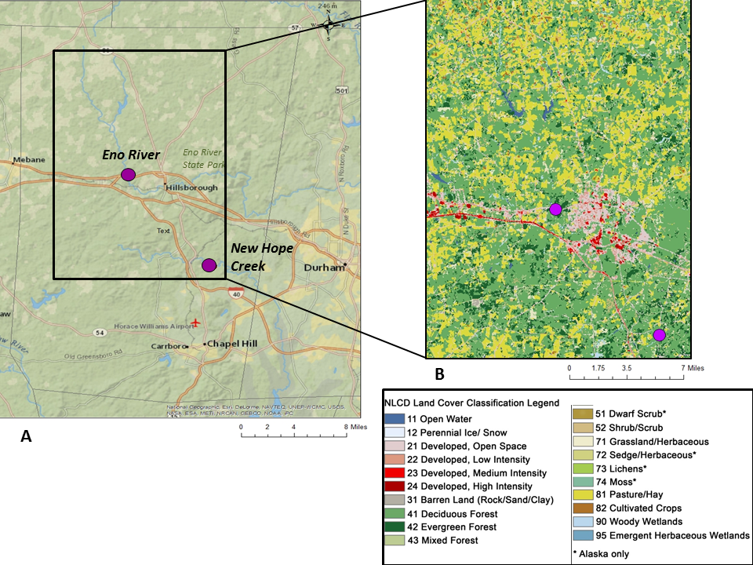
Figure 1: A) Orange County, North Carolina, United States of America with purple dots indicating sample sites. B) NLCD 2006 land cover map of enlarged area indicated by black outline showing primary land types upstream of sampling sites. Upstream regions are primarily Pasture/Hay, Deciduous Forest, Evergreen Forest for both locations.

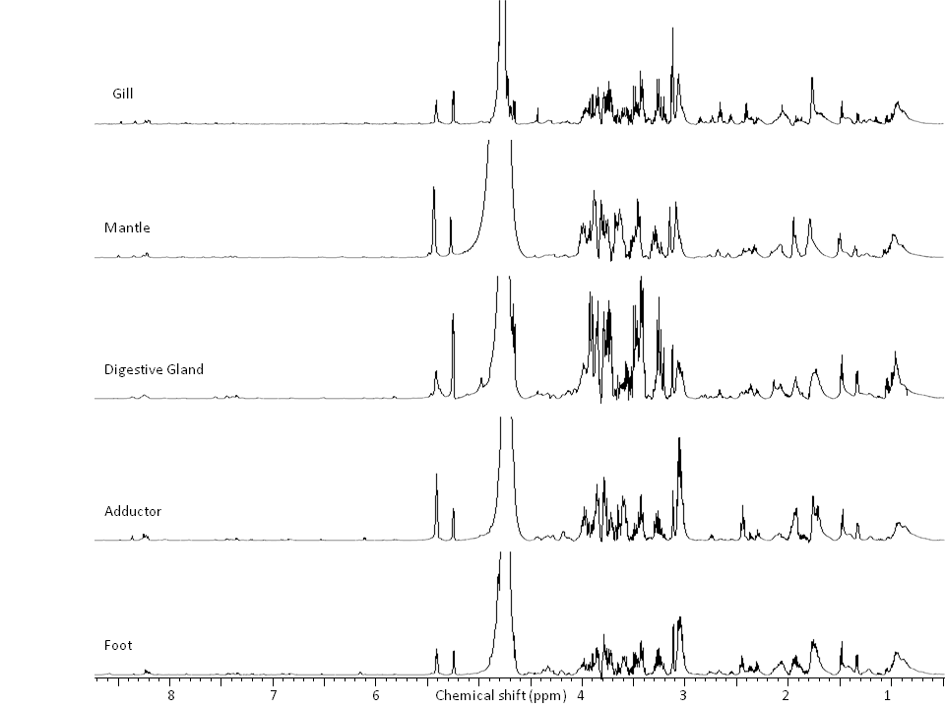
Figure 2: Representative ¹H-NMR spectra of each tissue from one individual.

Principal components analysis showed differentiation between tissue types (Figure 3). Variability along principal component 1 (PC1) partially separated the muscle tissues associated with amines and intermediates of amino acid metabolism from mantle, and digestive gland tissue associated with mono- and disaccharides and glycogen. Variability in principal component 2 (PC2) partially separated gill tissue associated with glutamate and several unidentified peaks from muscle tissues associated with amines and amino acid intermediates (Figure 4).
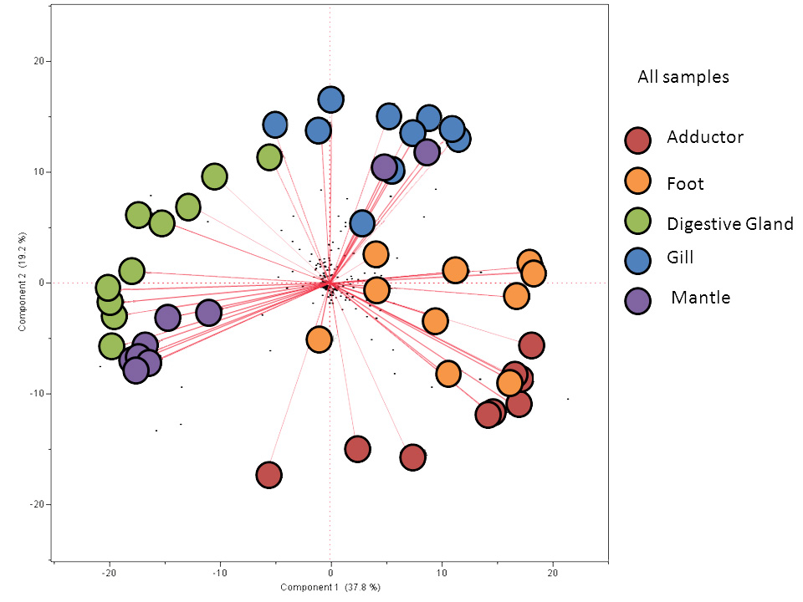
Figure 3: Two component principal components map of all samples from both rivers. Each tissue generally separates from the other indicating a characteristic metabolic profile for each tissue. The adductor and foot muscle profiles overlap indicating a relationship between the two muscle tissues. The two mantle samples that group with the gill samples are both female, this grouping may be due to seasonal reproductive changes to the mantle tissue.

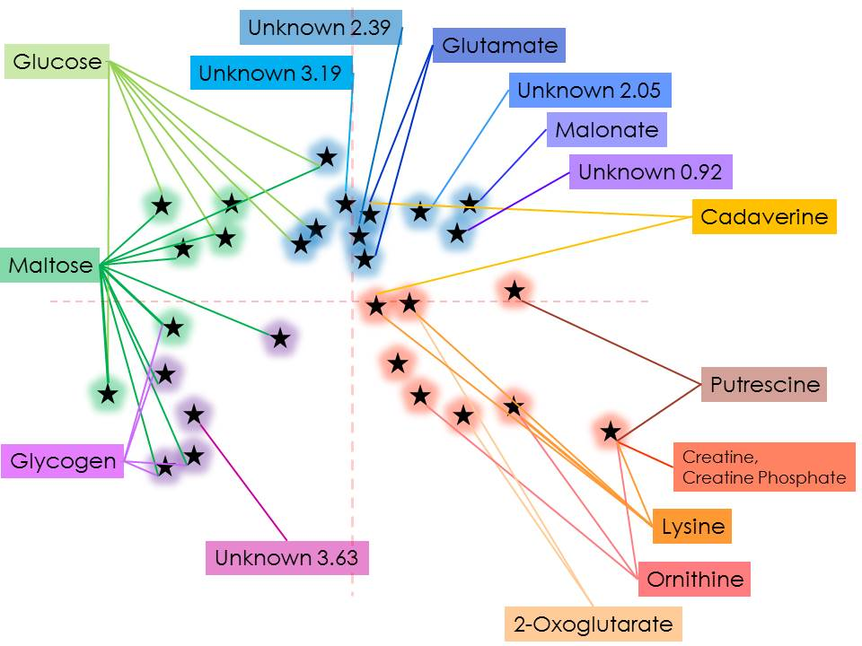
Figure 4: Loading plot of all tissue samples from both rivers. Blue stars correspond with scores within the gill grouping, green – digestive gland, purple – mantle, red – combined adductor and foot muscle.

Tissue associated variability was responsible for greater variation between samples than geographic location or sex when all samples were analyzed simultaneously. However, within tissue type, two variations were noted. A site effect for digestive gland samples was suggested by the noted variability along PC1 of glucose, maltose and glycogen, which separated the New Hope Creek digestive gland from the Eno River samples (Figure 5). Mantle tissue displayed an apparent sex effect. The three female samples grouped apart from the male samples regardless of site. This variability was noted along PC1 primarily in putrescine and two unknown resonances in the 0.85-0.93ppm (-CH₃) range and at 2.05ppm (likely CH₂C=O or CH₂C=C in structure) (Figure 6). The two mantle samples that grouped with the gill tissue samples in the overall PCA map (Figure 3) were both female. Little to no site- or sex-associated difference was observed in other tissues.

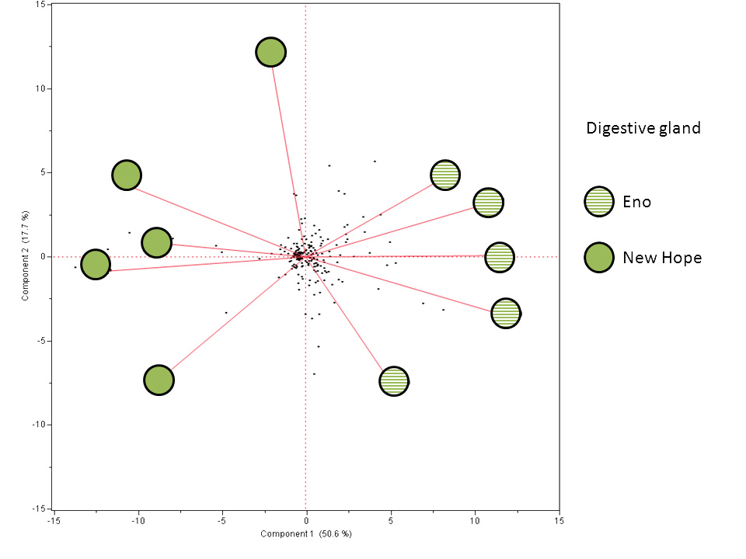
Figure 5: Tissue specific two-component principal components map of digestive gland samples. Eno River samples group separately from New Hope Creek samples suggesting location-specific effects on digestive gland metabolome.
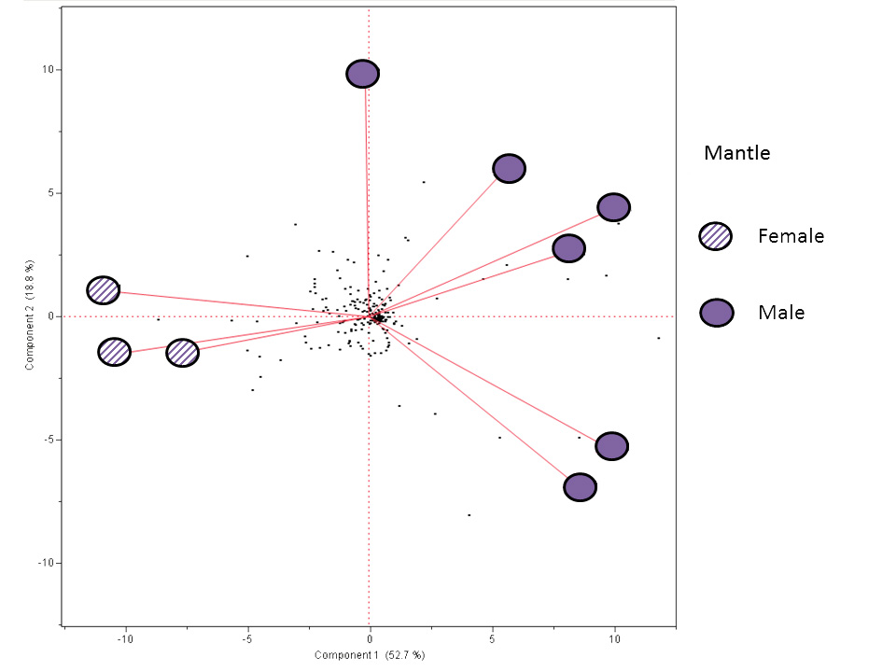
Figure 6: Tissue specific two-component principal components map of mantle samples. Samples from males group separately from female samples suggesting gender-specific effects on mantle metabolome.

Average water temperature, conductivity, pH, turbidity, oxygen and oxygen saturation measurements over the week prior to collection of mussels showed statistical differences between sites at the level of p<0.001 (n=572 per parameter, Tables 3, 4). Statistical analysis to compare the water quality parameters collected by the Isco samples obtained at the study sites was not possible because only two samples were collected at the New Hope Creek site. The collection tube for that apparatus was discovered to have been obstructed after aspiration of the first sample. A second sample was collected at the time of mussel collection that provided beginning and end samples for phosphate, ammonia, nitrate, nitrite, alkalinity, and hardness (n=2, Table 3). The measured values of these parameters were similar to the samples collected at the same time points as the Eno River and occurred within the range of the Eno River samples (n=18, n=9 for phosphate, Table 3). No measurements from either the Eno River or the New Hope Creek were above EPA criteria for drinking water (www.epa.gov).
Discussion
This study serves as a preliminary investigation of the use of metabolomic techniques for the study of freshwater mussels. We sampled a small number of Elliptio complanata, a freshwater mussel common in North Carolina from two watersheds in Orange County, NC (Figure 1) to identify the predominant polar endogenous metabolites in several tissues as a first step in evaluating the application of NMR spectroscopy as a tool to study freshwater mussel metabolism. Our study yielded identifiable metabolite spectra for six of the seven tissues sampled, suggested tissue-based differences in metabolic profile with overlap of the two muscle tissue types, and gave preliminary information about possible gender and diet differences in metabolic profile.

Hemolymph samples extracted from the anterior adductor muscle of mussels did not yield useful spectra in this study, despite promising results from another Unionid species tested in our lab, suggesting that hemolymph is not a useful diagnostic tissue for NMR analysis of Elliptio complanata metabolism. Few peaks were visible above baseline noise potentially because of low concentrations of metabolites in this biofluid. Hemolymph extraction and analysis has been effectively shown to identify physiologic parameters in freshwater mussels (Gustafson et al., 2005b) and additional efforts at using hemolymph for metabolic analysis are warranted. Although the maximum amount of hemolymph was aspirate from each individual, larger volumes of hemolymph from larger individuals or pooling of samples may allow for concentration techniques to be employed to yield a more useful metabolomic profile. However, in lab efforts to perturb hemolymph values as analyzed by standard hematologic biochemical analyzers through starvation and exposure to toxicants such as polychlorinated biphenyls have been unrewarding (unpublished work).

All identified metabolites were found in all tissues other than hemolymph, with each tissue having a characteristic pattern of metabolites (Figures 2, 3). Many of the metabolites found in E. complanata have been identified in American oyster (Crassostrea virginica) tissues using proton NMR, however, there were two notable differences in the bivalve metabolomes. First, the high concentrations of osmolytes seen in the oyster (Tikunov et al., 2010) were not seen in E. complanata. This absence of osmolytes may reflect evolutionary adaptations of the mussel to the low osmolarity of their freshwater environment (Dietz and Branton, 1975). Second, Elliptio complanata tissues contained predominant peaks of the polyamines putrescine and cadaverine not identified in oyster tissue (Tikunov et al., 2010). The physiologic significance of these polyamines in the sampled freshwater mussels is unknown. However, putrescine and cadaverine are products of amino acid metabolism and these biogenic amines have been documented in fish and other aquatic species (Hu et al. 2012).

In this study, despite significant differences (p<0.001) in temperature, conductivity, pH, turbidity, and dissolved oxygen, principal components analysis of all spectra simultaneously suggested that tissue type influenced sample grouping more than river site (Table 4, Figure 3). This may suggest that the water quality and food resources of both rivers fell within a range that allows normal metabolic functioning for E. complanata, or that, although significant, the variation was minor. It may also indicate that the study sites are functionally very similar despite statistical differences in water parameters noted. Both sites were located in wooded areas, upstream from a road bridge and the land-use of the upstream watershed is similar, although the Eno River site has more downstream development than the New Hope Creek site (Figure 1). Little is reported regarding a “normal” range of abiotic habitat requirements for E. complanata, however, our water quality measurements for both rivers were within the ranges of what has been measured in other studies using E. complanata or other unionids (Matteson, 1948; Griffiths and Cyr, 2006; Kessler et al., 2007; Cummings and Graf, 2010; Aldridge et al., 1987). In this preliminary analysis, our study sampled animals from only two sites, one in each of two similar rivers. To identify geographic effects on the metabolism of E. complanata more study sites and a larger number of animals from each site would need to be studied.
The principal components groupings by tissue likely reflect differences in physiologic function. Analysis of the principal components loadings plot highlights the metabolites that characterize each tissue grouping (Figure 4).
Digestive gland, characterized along PC1 by the carbohydrate metabolites glycogen, maltose and glucose, primarily functions an organ of digestion but also serves as a site for carbohydrate storage (Thompson et al., 1974; Tikunov et al., 2010). This tissue was the only tissue where a metabolomic difference by location was noted based on single tissue principal component analysis. A clear division by location was seen, primarily along PC1, separating Eno from New Hope samples by relative concentrations of glucose, maltose and glycogen (Figure 5) with New Hope samples having a greater relative concentration of maltose. This difference could be due to site-associated variation in nutritional status as measured by carbohydrate storage or reflect the gastrointestinal contents. Bacterioplankton and bacterial sediment populations vary greatly in different streams (Crump and Hobbie, 2005; Bucci et al., 2014) and the measured metabolites may not reflect a primary difference in the metabolome of the mussels themselves. The influence of microbial metabolomes or metabolism, either in the gut or on epidermal surfaces, on the metabolome of the mussel is to the best of our knowledge, unknown. A next level of investigation with gut depuration techniques and larger numbers of individuals would elucidate whether the difference in metabolome is related to nutrition, individual variation or other unidentified exogenous site-related influence.
Muscle tissue makes primary use of carbohydrates to meet energy needs during aerobic metabolism, however, bivalves may switch to protein stores under periods of stress resulting in increased pools of free amino acid intermediates and end products (De Zwann and Wijsman, 1976; Zurburg and De Zwann, 1981). In this study Elliptio complanata muscle tissues were differentiated from other tissue samples by the relative concentrations of the amines lysine, ornithine, putrescine, and cadaverine and the Krebs cycle intermediate, 2-oxoglutarate. Polyamines such as ornithine-derived putrescine and lysine-derived cadaverine have been found in a wide variety of animal and plant tissues and have been shown to participate in a large number of metabolic reactions, however their role as intermediate metabolites remains unclear (Jänne et al., 2004; Tabor and Tabor, 1975). They appear to have multiple functions in cellular metabolism including both promotion of cell proliferation and induction of apoptosis (Jänne et al., 2004). The prominence of putrescine deserves further investigation to better understand the role of polyamines in freshwater mussel physiology. Levels of putrescine have been shown to transiently decrease in response to paraquat exposure in the gastropod mollusk Biomphalaria glabrata (Cochón et al., 2007) suggesting that putrescine concentrations in tissues may be a useful biomarker for toxicant-associated oxidative damage.
Gill tissue is used by freshwater bivalves for respiration, food prehension and sorting, and in reproduction. The diversity of these functions makes it reasonable to postulate the need for gill tissue to produce a wide variety of metabolites. The prominent unknown peaks in the 0-6ppm range consistent with methyl groups (-CH₃) and alkenes (C_{n}H_{2n}) found in our study suggest that gill tissue may have relatively increased levels of lipoproteins or steroid hormones (Fan and Lane, 2008). These metabolites are too large for adequate detection and identification using the 1H-NMR techniques used in our study, but it would not be unexpected for portions of these molecules to overlap the low-molecular weight spectrum (Brown et al., 2008).

Like gill tissue, unionid mantle tissue is seasonally involved in reproduction, particularly in females. When ready to release their larvae, many gravid female freshwater mussel species transform the margins of their mantle into elaborate displays to attract fish that act as a host for the transformation of the larvae into juvenile mussels (Grabarkiewicz and Davis, 2008). Our mantle samples were characterized primarily by carbohydrate metabolites, which reflects the role of the mantle as a primary site of carbohydrate storage for bivalves (Patterson et al., 1999; Ojea et al., 2004; Tikunov et al., 2010), however, two of the mantle samples from the Eno River grouped with the gill samples based on principal components analysis. This may be related to the influence of macromolecular lipids or steroid hormones related to reproductive status, as both of these samples were female (De Zwann and Wijsman, 1976; Cavaletto and Gardner, 1999). When only mantle tissue is evaluated, all three female samples separate from the male samples, regardless of location (Figure 6). The three female mussels separated from the male mussels along PC1 with glycogen, glucose and maltose peaks associated with the male mussels. Relative differences in putrescine, cadaverine, and lysine peaks along with Unknown 1, which is suspected to be lipoprotein overlap, characterize female mantle samples. Earlier studies also noted a gender-related division by principal components analysis in the mantle metabolome of Mytilus galloprovincialis using (Hines et al., 2007), although the metabolites associated with gender varied from those found in our study with the exception of lysine. Longitudinal studies with more balanced sex ratios to assess seasonal changes in the metabolome are needed to better characterize the impact of reproductive status on the metabolome of freshwater mussels.
Conclusion
With the use of proton NMR, we observed relative concentration differences in metabolites in different tissues. More extensive study that can establish necessary confidence intervals for baseline values is needed to identify the metabolomic responses of different tissues to environmental changes. Additional studies are needed to determine which tissue sample best reflects metabolic changes in response to a given stimulus and to identify the most appropriate tissues for assessing particular environmental impacts. Our studies represent an initial step toward understanding the prominent metabolites that characterize freshwater mussel tissue and understanding how metabolomic studies can inform efforts to understand freshwater mussel health and disease.
Funding
This project was funded in part by the North Carolina Department of Transportation (# RP 2013-34); the United States Fish and Wildlife Service (#F09AP00051); and the North Carolina State University Hoffman Fellowship.
Acknowledgements
The authors are particularly grateful to Chris Eads, RiverNet (Ted Dodson and Jerry O’Connor), Hanna Gracz, Jeffery Macdonald, Andrey Tikunov, and Andeline Croce for technical and logistical support.
References

Aldridge DW, Payne BS, Miller AC (1987) The Effects of Intermittent Exposure to Suspended solids and turbulence on three species of freshwater mussels. Environ Pollut 45:17-28.
Ahuja I, de Vos RCH, Bones AM, Hall RD (2010) Plant molecular stress responses face climate change. Trends Plant Sci 15:664-680.
Bayne B (1973) Aspects of the metabolism of Mytilus edulis during starvation. Neth J Sea Res 7: 399-410.
Beckonert O, Keun HC, Ebbels TMD, Bundy J, Holmes E, Lindon JC, Nicholson JK (2007) Metabolic profiling, metabolomics and metabonomic procedures for NMR spectroscopy of urine, plasma, serum and tissue extracts. Nature Protocols 2:2692-2703.
Bedford JJ (1973) Osmotic relationships in a freshwater mussel, Hyridella menziesi Gray (Lamellibranchia: Unionidae). Arch Int Physio Biochem 81:819-831.
Berg DJ, Haag WR, Guttman SI, Sickel JB (1995) Mantle biopsy: a technique for nondestructive tissue-sampling of freshwater mussels. J N Am Benthol Soc 14:577-581.
Bogan AE (1993) Freshwater Bivalve Extinctions (Mollucsa: Unionoida): A search for causes. American Zoologist 33:599-609.
Brown SAE, Simpson AJ, Simpson MJ (2008) Evaluation of sample preparation methods for nuclear magnetic resonance metabolic profiling studies with Eisenia fetida. Environ Toxicol Chem 27:828-836.
Bucci JP, Szempruch AJ, Caldwell JM, Ellis JC, Levine JF (2014) Seasonal changes in microbial community structure in freshwater stream sediment in a North Carolina river basin. Diversity 6: 18-32.
Bundy JG, Keun HC, Sidhu JK, Spurgeon DK, Svendsen C, Kille P, Morgan AJ (2007) Metabolic profile biomarkers of metal contamination in a sentinel terrestrial species are applicable across multiple sites. Environ Sci Technol 41:4458-4464.
Bundy JG, Davey MP, Viant MR (2009) Environmental metabolomics: a critical review and future perspectives. Metabolomics 5:3-21.
Cavaletto JF, Gardner WS (1999) Seasonal dynamics of lipids in freshwater benthic invertebrates. In: MT Arts, Wainman BC, eds. Lipids in Freshwater Ecosystems. Springer, New York, pp. 109-126.
Cloarec O, Dumas ME, Craig A, Barton RH, Trygg J, Hudson J, Blancher C, Gauguier D, Lindon JC, Holmes E, Nicholson JK, (2005) Statistical Total Correlation Spectroscopy: An exploratory approach for latent biomarker identification from metabolic ¹H NMR data sets. Anal Chem 77:1282-1289.
Chittick B, Stoskopf M, Law M, Overstreet R, Levine J (2001) Evaluation of potential health risks to Eastern Elliptio (Elliptio complanata) (Mollusca: Bivalvia: Unionida: Unionidae) and implications for sympatric endangered freshwater mussel species. J Aquat Ecosyst Stress Recovery 9:35-42.
Cochón AC, Della Penna AB, Kristoff G, Piol MN, San Martín de Viale LC, Verrengia Guerrero NR (2007) Differential effects of paraquat on oxidative stress parameters and polyamine levels in two freshwater invertebrates. Ecotox Environ Safe 68:286-292.
Crump BC, Hobbie JE (2005) Synchrony and seasonality of bacterioplankton communities of two temperate rivers. Limnol Oceanogr 50:1718-1729.
Cummings KS, Graf DL (2010) Mollusca: Bivalvia. In: JH Thorp, AP Covich, eds. Ecology and Classification of North American Freshwater Invertebrates, Third edition. Elsevier, Boston, pp 309-384.
De Zwann A, Wijsman TCM (1976) Anaerobic metabolism in Bivalvia (Mollusca): Characteristics of anaerobic metabolism. Comp Biochem Physiol 54B:313-324.
Dietz TH (1974) Body fluid composition and aerial oxygen consumption in the freshwater mussel, Ligumia subrostrata (Say): Effects of dehydration and anoxic stress. Biol Bull 147:560-572.
Dietz TH, Branton WD (1975) Ionic regulation in the freshwater mussel, Ligumia subrostrata (Say). J Comp Physio 104:19-26.
Doyette A, Cossu C, Jacquin M, Babut M, Vasseur P (1997) Antioxidant enzymes, glutathione, and lipid peroxidation as relevant biomarkers of experimental or field exposure in the gills and the digestive gland of the freshwater bivalve, Unio tumidus. Aquat Toxicol 39:93-110.
Fan TWM (1996) Metabolite profiling by one- and two-dimensional NMR analysis of complex mixtures. Prog Nucl Mag Res Spec 28:161-219.
Fan TWM, Lane AN (2008) Structure-based profiling of metabolites and isotopomers by NMR. Prog Nucl Mag Res Spec 52: 9-117.
Gäde G, Wilps H (1975) Glycogen degradation and end products of anaerobic metabolism in the fresh water bivalve Anodonta cygnea. J Comp Physiol 104:79-85.
Gagné F, Cejka P, André C, Hausler R, Blaise C (2007) Neurotoxicological effects of a primary and ozonated treated wastewater on freshwater mussels exposed to an experimental flow-through system. Comp Biochem Phys C: 460-470.
Gasparini S, Audit C (2000) The free guanidine and polyamine pools of bivalve mollusks in relation to their ecology. Biochem Sys Ecol 28:209-218.
Gibb JOT, Holmes E, Nicholson JK, Weeks JM (1997) Proton NMR spectroscopic studies on tissue extracts of invertebrate species with pollution indicator potential. Comp Biochem Physio. 118B:587-598.
Goldberg ED (1986) The Mussel Watch Concept. Environ Monitor Assess 7: 91-103.
Grabarkiewicz JD, Davis WS (2008) Freshwater Mussels as Biological Indicators: Including Accounts of Interior Basin, Cumberlandian, and Atlantic Slope Species. U.S. Environmental Protection Agency, Office of Environmental Information, Washington DC. 122pp.
Griffiths NA, Cyr H (2006) Are there hot spots for Elliptio complanata in the shallow littoral zone of a large Canadian Shield lake? Can J Fish Aquat Sci 63:2137-2147.
Gustafson LL, Stoskopf MK, Bogan AE, Showers W, Kwak TJ, Hanlon S, Levine JF (2005a) Evaluation of a nonlethal technique for hemolymph collection in Elliptio complanata, a freshwater bivalve (Mollusca: Unionidae). Dis of Aquat Organ 65:159-165.
Gustafson LL, Stoskopf MK, Showers W, Cope WG, Eads C, Linnehan R, Kwak TJ, Andersen B, Levine JF (2005b) Reference ranges for hemolymph chemistries from Elliptio complanata of North Carolina. Dis Aquat Organ 65:167-176.
Hanson JA, Dietz TH (1976) The role of free amino acids in cellular osmoregulation in the freshwater bivalve Ligumia subrostrata (Say). Can J Zool 54:1927- 1931.
Hines A, Oladiran GS, Bignell JP, Stentiford GD, Viant MR (2007) Direct Sampling Organisms from the Field and knowledge of their phenotype: Key recommendations for environmental metabolomics. Environ Sci Technol 41:3375-3381.
Hochachka PW, Mustafa T (1972) Invertebrate facultative anaerobiosis. Science 178:1056-1060.
Holliman FM, Davis D, Bogan AE, Kwak TJ, Cope WG, Levine JF (2008) Magnetic resonance imaging of live freshwater mussels (Unionidae). Invertebr Biol 127:396-402.
Hu, Y, Huang, Z, Li J, Yang H (2012) Concentrations of biogenic amines in fish, squid and octopus and their changes during storage. Food Chem 135:2004-2611.
Hurley-Sanders JL, Stoskopf MK, Nelson SAC, Showers W, Gracz HS, Levine JF (2014) Tissue extraction methods for metabolic profiling of a freshwater bivalve, Elliptio complanata (Lightfoot, 1786). Am Malacol Bull – under review.
Jänne J, Alhonen L, Pietilä M, Keinänen TA (2004) Genetic approaches to the cellular functions of polyamines in mammals. Eur J Biochem 271:877-894.
Kessler DH, Newton TJ, Green L (2007) Long-term monitoring of growth in the Eastern Elliptio, Elliptio complanata (Bivalvia: Unionidae), in Rhode Island: a transplant experiment. J N Am Benthol Soc 26:123-133.
Lehmann DW, Levine JF, Law JM (2007) Polychlorinated biphenyl exposure causes gonadal atrophy and oxidative stress in Corbicula fluminea clams. Toxicol Pathol 35:356-365.
Liu, X, Zhang L, You L, Yu J, Cong M, Wang Q, Li F, Li L, Zhao J, Li C, Wu H (2011) Assessment of clam Ruditapes philippinarum as heavy metal bioindicators using NMR-based metabolomics. Clean-Soil Air Water 39:759-766.
Long SD, Rodrick GE, Friedl FE (1984). Succinate dehydrogenase in various tissues of Anodonta couperiana, Elliptio buckleyi and Mercenaria campechiensis (Mollusca: Bivalvia). Comp Biochem Physiol 78B:467-472.
Matteson MR (1948) Life History of Elliptio complanatus (Dillwyn, 1817). Am Midl Nat 40: 690-723.
Naimo TJ, Damschen ED, Rada RG, Monroe EM (1998) Nonlethal evaluation of the physiological health of unionid mussels: methods for biopsy and glycogen analysis. J N Am Benthol Soc 17:121-128.
Ojea J, Pazos AJ, Martínez D, Novoa S, Sánchez JL, Abad M (2004) Seasonal variation in weight and biochemical composition of the tissues of Ruditapes decussatus in relation to the gametogenic cycle. Aquaculture 238:451-468.
Páez-Osuna F, Osuna-López JI, Izaguirre-Fierro G, Zazueta-Padilla HM (1993a) Heavy metals in oysters from a subtropical coastal lagoon associated with an agricultural drainage basin. Bull Environ Contam Toxicol 50:696-702.
Páez-Osuna F, Osuna-López JI, Izaguirre-Fierro G, Zazueta-Padilla HM (1993b) Heavy metals in clams from a subtropical coastal lagoon associated with an agricultural drainage basin. Bull Environ Contam Toxicol 50:915-921.
Patterson MA, Parker BC, Neves RJ (1999) Glycogen concentration in the mantle tissue of freshwater mussels (Bivalvia: Unionidae) during starvation and controlled feeding. Am Malacol Bull 15:47-50.
Peñuelas J, Sardans J (2009) Elementary Factors. Nature 460:803-804.
Spann N, Aldridge DC, Griffin JL, Jones OAH (2011) Size-dependent effects of low level cadmium and zinc exposure on the metabolome of the Asian clam, Corbicula fluminea. Aquat Toxicol 105:589-599.
Rosenblum ES, Tjeerdema RS, Viant MR (2006) Effects of temperature on host-pathogen-drug interactions in red abalone Haliotis rufescens determined by ¹H NMR metabolomics. Environmental Science and Technology 40:707-7084.
Tabor CW, Tabor H (1976) 1,4-Diaminobutane (putrescine), spermidine, and spermine. Annu Rev Biochem 45:285-306.
Thompson RJ, Ratcliffe NA, Bayne BL (1974) Effects of starvation on structure and function in the digestive gland of the mussel (Mytilus edulis L.). J Mar Biol Assoc UK 54:699-712.
Tikunov AP, Johnson CB, Lee H, Stoskopf MK, Macdonald JM (2010) Metabolomic Investigations of American Oysters Using 1H-NMR Spectroscopy. Marine Drugs 8:2578-2596.
Vaughn CC, Hakenkamp CC (2001) The functional role of burrowing bivalves in freshwater ecosystems. Freshwater Biology 46:1431-1446.
Viant MR, Rosenblum ES, Tjeerdema RS (2003) NMR-based metabolomics: A powerful approach for characterizing the effects of environmental stressors on organism health. Environ Sci Technol 37: 4982-4989.
Williams JD, Warren ML, Cummings KS, Harris JL, Neves RJ (1993) Conservation status of freshwater mussels of the United States and Canada. Fisheries 18:6-22.
Won SJ, Novillo A, Custodia N, Rie MT, Fitzgerald K, Osada M, Callard I (2005) The Freshwater Mussel (Elliptio complanata) as a Sentinel Species: Vitellogenin and Steroid Receptors. Integr Comp Biol 45:72-80.
Zhang L, Liu X, You L, Zhou D, Wu H, Li L, Zhao J, Feng J, Yu L (2011) Metabolic responses in gills of Manila clam Ruditapes philippinarum exposed to copper using NMR-based metabolomics. Mar Environ Res 72:33-39.
Zurburg W, De Zwann A (1981) The role of amino acids in anaerobiosis and osmoregulation in bivalves. J Exp Zool 215:315-325.

Table 1: Shell measurements (length, height, width) and median measurements for sampled Elliptio complanata in millimeters.
NH = New Hope Creek, E = Eno River,* = non-gravid female, all other mussels were male
 | Length | Height | Width |  | Length | Height | Width
NH1 | 59 | 32 | 19 | E1* | 65 | 42 | 25
NH2 | 61 | 36 | 19 | E2 | 64 | 39 | 23
NH3 | 70 | 42 | 21 | E3* | 72 | 41 | 23
NH4 | 58 | 33 | 22 | E4 | 58 | 33 | 22
NH5 | 69 | 40 | 24 | E5* | 69 | 40 | 24
Median | 61 | 36 | 21 | Median | 65 | 40 | 23

Table 2: Suggested major metabolites and peak assignments. (s: singlet, br.s: broad singlet, d: doublet, dd: doublet of doublets, t: triplet, m: multiplet)
 |  | Metabolites |  | Chemical shift and peak shape, ppm* | Reference
Amino acids |  | Alanine |  | 1.46(d), 3.76(m) | [1] [2]
 |  | Arginine |  | 1.68(m), 1.90(m), 3.23(m), 3.74(m) | [1] [3]
 |  | Glutamate |  | 2.08(m), 2.34(m), 3.74(t) | [1] [3] [6]
 |  | Glycine |  | 3.54(s) | [1] [3]
 |  | Isoleucine |  | 0.92(t), 1.00(d), 1.26(m), 1.44(m), 1.96(m), 3.66(d) | [1] [3] [4]
 |  | Leucine |  | 0.94(d), 0.96(d), 1.66(m), 3.71(t) | [1] [3] [4]
 |  | Serine |  | 3.84(m), 3.96(m) | [1] [4]
 |  | Taurine |  | 3.25(t), 3.42(t) | [1] [5]
 |  | Valine |  | 0.98(d), 1.03(d), 2.25(m), 3.59(d) | [1] [3] [4]
Energy Related |  | Glucose |  | 3.23(dd), 3.40(m), 3.46(m), 3.52(dd), 3.73(m), 3.82(m), 3.88(dd), 4.63(d), 5.22(d) | [1] [4]
 |  | Glycogen |  | 3.40(m), 3.60(m), 3.80(m), 3.96(br.s.), 5.40(br.s.) | [1] [2]
 |  | Maltose |  | 3.27(dd), 3.41(t), 3.58(m), 3.62(m), 3.66(m), 3.70(m), 3.76(m), 3.84(m), 3.90(dd), 3.93(d), 3.96(m), 5.22(d), 5.40(d) | [0]
 |  | ADP |  | 4.15(m), 4.16(m), 4.57(m), 5.94(m), 8.29(s), 8.54(s) | [1] [4] [6]
 |  | ATP |  | 4.21(m), 4.28(m), 4.39(m), 4.51(m), 4.62(t), 6.13(d), 8.24(s), 8.53(s) | [1] [4] [6]
 |  | Acetate |  | 1.91(s) | [2]
 |  | 2-oxoglutarate |  | 2.43(t), 3.00(t) | [3] [6]
 |  | Pyruvate |  | 2.46(s) | [2]
 |  | Lactate |  | 1.32(d), 4.10(q) | [2]
Osmolytes/Organic acids
 |  | Betaine |  | 3.25(s), 3.89(s) | [1] [4]
 |  | ß-alanine |  | 2.55(t), 3.18(t) | [1]
 |  | GABA |  | 1.89(m), 2.28(t), 3.00(t) | [9]
Krebs Cycle Intermediates
 |  | Succinate |  | 2.41(s) | [1] [7]
 |  | Fumarate |  | 6.51(s) | [7]
Fatty acid metabolism
 |  | Malonate |  | 3.11(s) | [7]
 |  | Carnitine |  | 2.43(dd), 3.21(s), 3.42(m), 4.56(2) | [1]
Polyamine metabolism
 |  | Cadaverine |  | 1.45(m), 1.71(m), 3.01(t) | [8]
 |  | Ornithine |  | 1.73(m), 1.83(m), 1.93(m), 3.05(t), 3.77(t) | [4]
 |  | Putrescine |  | 1.75(m), 3.04(t) | [4]
Unknown | Unknown 1 |  | 0.92(0.8 to 0.93 - multiple overlapping peaks) |  |  | Unknown peak 2 2.05(br.s)
Unknown | Unknown peak 3 |  | 2.39(t) |  |  | Unknown peak 6 |  |  | 3.19(s)
Unknown | Unknown peak 4 |  | 2.64(t) |  |  | Unknown peak 7 |  |  | 3.24(m)
 |  | Unknown peak 5 |  | 2.84(m) | Unknown peak 8 |  | 3.63(br.s)
[1] Tikunov et al., 2010 [2] Gade and Wilps, 1975 [3] Hanson and Dietz, 1976 [4] Spann et al., 2011 [5] Bedford, 1973[6] Hochachka and Mustafa, 1972 [7] Long et al., 1984 [8] Gasparini and Audit, 2000 [9] Gagne et al., 2007, [0] No definitive reference found for maltose in bivalves outside the digestive tract. *Chemical shifts identified using the HMDB, BMRB, and Chenomx NMR Suite 7.6
Table 3: Descriptive statistics for water quality parameters collected from the Eno River and New Hope Creek. Median, mean and standard deviation not calculated for New Hope samples collected by ISCO due to small sample number, one sample was collected at time of equipment deployment and at time of equipment collection a week later. (Temp=temperature, Cond=conductivity, pH, Turbid=turbidity, ODOsat=optical dissolved oxygen saturation, ODO=optical dissolved oxygen, NO₃=nitrate, NO₂=nitrite, Alk=alkalinity (as CaCO₃), Hard=hardness, NH₃=ammonia, PO₄=phosphate).
Eno River
 | YSI 6920 |  |  |  |  |  |  |  |  | ISCO
 | Temp | Cond |  | pH |  | Turbid |  | ODOsat |  | ODO |  | NO3 |  | NO2 |  | Alk |  | Hard |  | NH3 |  |  | PO4
 | C | mS/cm |  |  |  | NTU |  | % |  | mg/L |  | mg/L |  | mg/L |  | mg/mL |  | mg/L |  | mg/L |  |  | ppm
mean | 18.25 | 0.078 |  | 7.04 |  | -0.144 |  | 84.83 |  | 8.01 |  | 0.22 |  | 0.02 |  | 35 |  | 40.9 |  | -0 |  |  | 0
max | 24.7 | 0.189 |  | 7.22 |  | 9.5 |  | 101.1 |  | 8.86 |  | 1.6 |  | 0.03 |  | 40 |  | 51.3 |  | 0.2 |  |  | 0.1
median | 18.3 | 0.077 |  | 7.03 |  | -0.1 |  | 84.4 |  | 8.02 |  | 0.15 |  | 0.02 |  | 35 |  | 34.2 |  | -0 |  |  | 0
min | 14.2 | 0.009 |  | 6.52 |  | -5.4 |  | 81.1 |  | 7.04 |  | -0.9 |  | 0.01 |  | 30 |  | 34.2 |  | -0.1 |  |  | 0.1
stdev | 2.95 | 0.007 |  | 0.07 |  | 4.32 |  | 2.4 |  | 0.49 |  | 0.65 |  | 0.01 |  | 2.42 |  | 2.02 |  | 0.1 |  |  | 0
N | 572 | 572 |  | 572 |  | 572 |  | 572 |  | 572 |  | 18 |  | 18 |  | 18 |  | 18 |  | 18 |  |  | 9
New Hope Creek
 | YSI 6920 |  |  |  |  |  |  |  |  | ISCO
 | Temp | Cond |  | pH |  | Turbid |  | ODOsat |  | ODO |  | NO3 |  | NO2 |  | Alk |  | Hard |  | NH3 |  |  | PO4
 | C | mS/cm |  |  |  | NTU |  | % |  | mg/L |  | mg/L |  | mg/L |  | mg/mL |  | mg/L |  | mg/L |  |  | ppm
mean | 16.76 | 0.085 |  | 7.31 |  | 4.554 |  | 96.64 |  | 9.44
max | 21.2 | 0.103 |  | 7.62 |  | 142.1 |  | 114.2 |  | 11.9 |  | 0.8 |  | 0.02 |  | 40 |  | 51.3 |  | -0 |  |  | 0.1
median | 16.2 | 0.085 |  | 7.31 |  | 0.5 |  | 99.35 |  | 9.68
min | 13.3 | 0.002 |  | 7.16 |  | -10.1 |  | 83 |  | 7.69 |  | -0.2 |  | 0.02 |  | 40 |  | 51.3 |  | -0 |  |  | 0.1
stdev | 2.56 | 0.011 |  | 0.04 |  | 17.08 |  | 6.87 |  | 1.1
N | 572 | 572 |  | 572 |  | 572 |  | 572 |  | 572 |  | 2 |  | 2 |  | 2 |  | 2 |  | 2 |  |  | 2

Table 4: Parameters and averages measured by YSI 6920 every 15 minutes over the span of one week between rivers. All parameters were significantly different between the two rivers at a p<0.001.
 |  | Welch Two Sample t-test
 | N |  | Eno mean | NH mean |  | p-value |  |  | 95% CI
Temperature (C) | 572 |  | 18.25 | 16.76 |  | <0.001 |  |  | (1.17, 1.82)
Conductivity (mS/cm) | 572 |  | 0.0779 | 0.0848 |  | <0.001 |  |  | (-0.0079, -0.0058)
pH | 572 |  | 7.04 | 7.31 |  | <0.001 |  |  | (-0.27, -0.26)
Turbidity (NTU) | 572 |  | 0.1442 | 4.554 |  | <0.001 |  |  | (-6.145, -3.252)
ODOsat (%) | 572 |  | 84.83 | 96.63 |  | <0.001 |  |  | (-12.41, -11.21)
ODO (mg/L) | 572 |  | 8.02 | 9.44 |  | <0.001 |  |  | (-1.53, -1.33)

